Procurement Strategy Approval

For completion by the
Procurement Officer(s)
and Service Lead(s)

PROCUREMENT JOURNEY – ROUTE 3
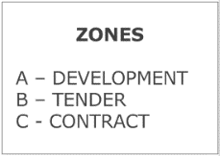
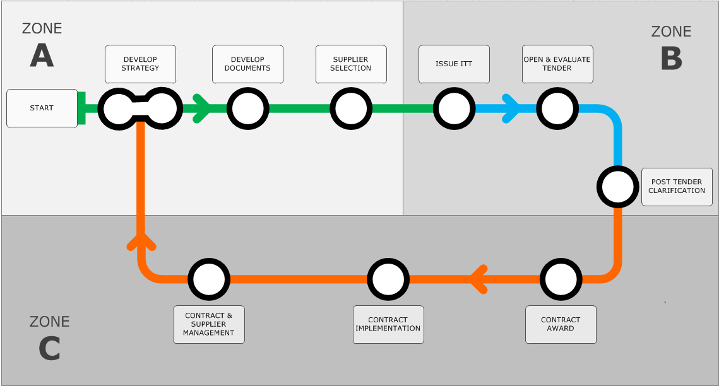

SECTION |  |  | - PROPOSED CONTRACT
 | CONTRACT DETAILS
Contract Title
Service Department |  |  |  |  | Reference Number | SBC/CPS/Click here to enter text.
Type of Contract  (choose appropriate) |  |  |  | Choose an item. | Category Type  (delete as appropriate) | Choose an item.
Proposed Contract Start Date |  |  |  | Click here to enter a date. | Proposed Contract End Date (including optional extensions) | Click here to enter a date.
Strategy Developed by: |  |  |  | Enter Procurement Officer Name(s) | Enter Service Officer Name(s) | Enter Other Name(s)

SECTION |  |  | - EXECUTIVE SUMMARY
The initial insights, options considered and recommended outcomes are based on a carefully considered view of the contract strategy development and show the key procurement considerations of the proposed contract.
 | KEY FINDINGS
Please overwrite/delete the text below:

Total spend is over £«value»: -«i.e. breakdown of spend by organisation»

Products purchased make up «No.» key sub-categories: -«i.e. breakdown of spend by sub-categories»;

More than x-number of suppliers are currently used to provide these products:
-«i.e. breakdown by supplier»

A sustainability test has been undertaken and the key sustainability issues identified.
 | BENCHMARKING & OPPORTUNITIES
Please overwrite/delete the text below:

Benchmarking and Opportunities, Options Considered;

Scope and Dependencies
-«i.e. Market Status, Collaborations Considerations, (Cross) Department/Service(s), Organisation (s) or sector( s) interested in proposed outcomes.
 | RECOMENDATIONS & KEY ACTIONS
Please overwrite/delete the text below:

After comprehensive consultation with stakeholders:
-«i.e. Procurement Process
-«i.e. To go to market using available framework (external, internal) or tender process»;
-«i.e. Award new contract/s by «date», with a phased implementation effective from «date».
 | BENEFITS, JUSTIFICATION & PROJECTED SAVINGS
Please overwrite/delete the text below:

Planned Savings Target
-«i.e. cashable/non-cashable savings»;
-«i.e. return on investment».
 | KEY RISKS & RESOURCE IMPLICATIONS
Please overwrite/delete the text below:

Key Risks - Potential Risks in the Procurement Process
-«i.e. Insufficient access to accurate and current spend data and current contract data»;
-«i.e. Insufficient stakeholder engagement and demonstrable commitment to required resource».

SECTION |  |  | - STRATEGY APPROVAL
 | STRATEGY SIGN OFF
Scheme of Delegation Overview for Strategy Approval and Requisition Approval within Business World:
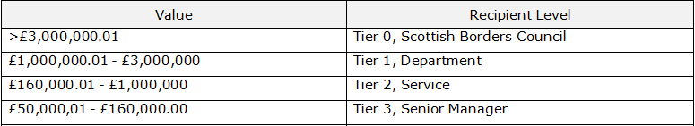

Please Note: For the acceptance and award of contracts the Chief Executive, Service Directors or Heads of Service will sign all goods and services and works contracts provided the procurement was carried out solely by the Council for the Council as detailed within Section 6 of the Procurement and Contract Standing Orders.
Procurement Approval (Commercial & Commissioned Services):
Procurement Business Partner/Social Care & Health Business Partner |  |  |  |  |  | Commercial & Commissioned Services Manager |  | Chief Financial Officer
Up to £160,000 |  |  |  |  |  | Up to £1,000,000 |  | Over £1,000,000
This section of the strategy requires sign off from the appropriate Officer.

Please Note: If the approved service lead is also the budget holder then sign-off by the next level of authority upwards in the Scheme of Delegation must be included within the strategy – self-approval is not appropriate.

Approved by appropriate |  |  |  |  | Commercial & Commissioned Services Officer or Chief Financial Officer
Name: |  |  |  |  |  |  | Position:
Signature: |  |  |  |  |  |  | Date: |  | Click here to enter a date.
Approved by appropriate |  |  |  |  | Service Officer
Name: |  |  |  |  |  |  | Position:
Signature: |  |  |  |  |  |  | Date: |  | Click here to enter a date.
Approved by appropriate |  |  |  |  | Budget Holder
Name: |  |  |  |  |  |  | Position:
Signature: |  |  |  |  |  |  | Date: |  | Click here to enter a date.
Approved by appropriate |  |  |  |  | Specialist Officer (e.g. IT Business Partner) – if required
Name: |  |  |  |  |  |  | Position:
Signature: |  |  |  |  |  |  | Date: |  | Click here to enter a date.

SECTION |  |  | - STAKEHOLDER IDENTIFICATION
 | STAKEHOLDERS (CROSS FUNCTIONAL TEAM)
Project Role |  |  |  | Name/Org | Signed Declaration | Evaluation Member
Budget Holder
Service Lead
Specialist Support
Procurement Lead
Finance
Legal Support
Others

SECTION |  |  | - PROFILING THE REQUIREMENT
 | CURRENT SITUATION/CONTRACT STATUS
This section should include details of any current contracts/agreements or spend activity together with appropriate background information in relation to what volume/value is currently being bought along with the frequency and reason for this activity. Consideration should be given to elements such as price, efficiencies, contract improvement, quality, service delivery, sustainability, equality & diversity, community benefits, contract management and training.

Current contract status (if applicable), highlighting where either current practice or contract could be improved (i.e. lessons learned from current contract, service area or suppliers).
Please list all relevant policies (external and internal) and legislation applicable to this procurement activity.
Potential Options  Click on above for list |  |  |  | Please list relevant policies below:

 | HISTORICAL SPEND INFORMATION
Total Expenditure (p.a.) |  | Supplier(s) | Comments

 | BUDGET INFORMATION
Budget Code |  |  | Budget Category  (choose appropriate) | Choose an item.
Available Budget for this Contract Project
Total Contract Value based on forecast figure
(including any optional extensions)

 | SUSTAINABILITY/COMMUNITY BENEFITS CONSIDERATIONS
Sustainable procurement is concerned with identifying the potential environmental, social and economic aspects that could be incorporated within a procurement process through the development of a relevant specification or through contract terms & conditions. It can even be achieved through voluntary contract management.

This section should include the potential sustainability areas that are relevant to the goods, services or works required and how they might be specified within the procurement process.
Please review the Purchasing Guidelines - Quick Reference Guide for further information and guidance on sustainability and community benefits.

Please complete the embedded Sustainability test with the Service Lead. For further advice please contact the Sustainability Officer (Procurement).
CCS > Performance & Development - CCS > P&D - SBC Procurement Journey > Route 3 > Route 3 Template Documents > Sustainability Test Protected V1 (March 2018)

This section should be completed using the outputs from the sustainability test.

Consider how all the identified opportunities and risks from the test will be included in the tender documents. If required please add additional rows.
Sustainability Consideration |  | Reference to tender documents
Environmental
Social and Economic

SUPPLY MARKET STATUS
This section should include a summary of the market analysis undertaken as part of the strategy development process. It should detail the current position within the supply market with regards to the goods & services or works required - Consider PEST/SWOT Analysis, Market Trends, Benchmarking, Current Supply Base and Supply Chain Management.

COLLABORATION CONSIDERATIONS
This section should detail the collaborative opportunities that could be available for the required commodities and whether they are appropriate to be utilised by the Council. Where a collaborative contract is available then the commodity strategy relating to this contract should be obtained for review.
Collaborative Opportunity
Lead Authority
Other Organisations involved

 | SME’s (SMALL MEDIUM ENTERPRISE)
Is there an opportunity to LOT the requirement to enable SME inclusion? |  |  | YES | NO
If requirements are to be lotted please detail the lots and the rationale behind these lot choices.
Lot Number and Detail |  | Rationale
If not Lotted please explain why below:

SECTION |  |  | - BEST VALUE OPPORTUNITIES ASSESSMENT
 | PURCHASE DEMAND MANAGEMENT
Reduce Consumption |  |  |  | Please overwrite/delete the text below:  - Business case to include estimated savings  - Eliminate need  - Challenge Demand  - Alternative ways of meeting need  - Policy Changes  - Reduce Maverick Spend  - Re-use and share products/services
Consolidate Spend |  |  |  | Please overwrite/delete the text below:  - Standardise specification  - Leverage departmental spend  - Collaboration  - Use of Framework Agreements  - Sustainability Compliance
Improve Specification |  |  |  | Please overwrite/delete the text below:  - Detailed specifications  - Cost driven specifications  - Optimise service levels  - Quantify spend volumes  - Future proof cost to supply sustainably  - Low impact/cost of disposal  - Specify durability

 | SUPPLY BASE MANAGEMENT
Restructure Relationships |  | Please overwrite/delete the text below:  - Develop strong relationships with preferred suppliers  - Supplier Development Programmes  - Use of Service Level Agreements  - Incentivise contracts  - PPI/PFI/PPP contracts  - Sustainability and Contract Management
Increase Competition |  | Please overwrite/delete the text below:  - Benchmark price/performance  - Value for money  - E-Auction  - Cost Breakdown Analysis  - Sustainability- build into supplier performance
Restructure Supply Base |  | Please overwrite/delete the text below:  - Mini Competition using existing collaborative contracts  - Tender requirements for all spend  - Use open book costing approach  - Supplier consolidation – framework agreements
 | TOTAL COST MANAGEMENT
Optimise Total Supply Chain Costs |  | Please overwrite/delete the text below:  - Design/development  - Integration of logistics  - Use existing frameworks to reduce lengthy tender processes  - Implement “Lean” supply techniques to minimise waste  - Work with suppliers to identify and prioritise options/alternatives for improvement
Reduce Total Ownership Costs |  | Please overwrite/delete the text below:  - Re-engineer processes  - Outsourcing  - Reduce inspection  - Reduce stock holding  - Consider disposal costs using TCO model  - Build sustainability into service developments
Reduce Transactions |  | Please overwrite/delete the text below:  - Rationalise requirements and suppliers  - Use GPC for low value transactions  - Consider use of e-procurement systems  - Consolidation of invoices  - Reduce resource through streamlined process and e-enablement  - Optimise delivery schedules, lot sizes and networks to reduce impact on environment

 | KEY RISKS
Risk |  | Probability (1-5) | Impact (1-5) | Risk Score | Actions required to manage Risk
The attached risk register should be completed to include risk areas that are relevant to the goods, services or works required. The attached guidance documents give examples of risks which may arise in the procurement process.

Any unmitigated risks that remain at the end of the Tender process must be handed over as part of the Tender Completion Process.
CPS > Performance & Development - CCS > P&D - SBC Procurement Journey > Route 3 > Route 3 Template Documents > Master Risk Register

CPS > Performance & Development - CCS > P&D - SBC Procurement Journey > Route 3 > Route 3 Template Documents > The Risk Matrix

CPS > Performance & Development - CCS > P&D - SBC Procurement Journey > Route 3 > Route 3 Template Documents > Potential Risk in the Procurement Process

SECTION |  |  | - PROPOSED CONTRACT BENEFITS
 | SAVINGS
Is the project part of existing Financial Plan savings? |  |  |  |  |  |  | YES |  | NO
Financial Year |  |  |  | Description | Value | Percentage |  | Savings Type
 |  |  |  |  |  |  |  | Choose an item.
 |  |  |  |  |  |  |  | Choose an item.
 |  |  |  |  |  |  |  | Choose an item.
Key Milestones to be linked to Payments and Invoicing Options (consolidated).

 | PLANNED CONTRACT BENEFITS – NON FINANCIAL
Consider ERP options such as accessing punch out facilities, supplier providing products using a standard upload template, submission of invoices by XML, use of purchase cards etc.
Description |  | Comment

 | PLANNED CONTRACT PERFORMANCE MEASURE (KPI’s)
This section should include the planned contract key performance indicators that applicable to this contract.
Description |  | Comment | Responsible Owner

CONTRACT IMPLEMENTATION/MOBILISATION
Consider timescales in relation to implementation and mobilisation of the contract following the award process.

SECTION |  |  | - CONSIDERATIONS
 | GENERAL DATA PROTECTION REGULATION (GDPR) CONSIDERATIONS
Are there any General Data Protection Regulation (GDPR) considerations?  (If “Yes” please complete section below using data from the Terms & Conditions – Schedule Data Protection). |  |  |  |  | Choose an item.
The subject matter and duration of the Processing of Personal Data are: |  |  |  | [insert description here]
The nature and purpose of the Processing of Personal Data: |  |  |  | [insert description here]
The type of Personal Data to be Processed: |  |  |  | [Include list of data types here]
The categories of Data Subject to whom Personal Data relates: |  |  |  | [Include categories of data subjects here]

PRIVACY NOTICE
For completion when processing personal and sensitive personal data.
Name or company to be included in the Privacy Notice:
CCS > Performance & Development - CCS > P&D - SBC Procurement Journey > Route 3 > Route 3 Template Documents > Privacy Notice Example

 | FURTHER CONSIDERATIONS
Non-involvement in Serious Organised Crime Requirements – Through discussion with the SPOC (Single Point of Contact) and review of the Non-Involvement in Serious Organised Crime Procedure and Guidelines has the proposed contract been identified as being in a risk sector? |  | Choose an item.
If the answer to the above is Yes then has the Non-Involvement in Serious Crime Policy been reviewed and Declaration forms prepared? |  | Choose an item.
If the Project Involves an Element of IT has IT been consulted?  (If “No” please ensure that you contact IT before progressing further).  (If “Yes” please ensure appropriate sign off at section 9). |  | Choose an item.
Is there a requirement for either a Parent Company Guarantee or Bond? |  | Choose an item.
Has the conflict of interest form been signed and returned to Procurement by all panel members?  (If “No” Procurement Lead to ensure that form is returned prior to commencing the evaluation process). |  | Choose an item.
Have the most appropriate Contract Terms & Conditions been identified to govern this Contract? If so please name below: |  | Choose an item.
Will TUPE apply? |  | Choose an item.
Is the proposed contract/project of politically sensitive nature? (If “Yes” please give details of actions taken below). |  | Choose an item.
Is the requirement or project sensitive? (If “Yes” please give details of actions taken below). |  | Choose an item.
Have Corporate Communications been involved/informed? (If “Yes” please give details of actions taken below). |  | Choose an item.
Are there any Health and Safety considerations within the specification that require discussion and/or input from SBC’s Wellbeing and Safety team? |  | Choose an item.
Have you reviewed all the SPPN documents and are these incorporated and/or considered within the tender documents?  Scottish Government Procurement Policy Notes (SPPN) |  | Choose an item.
Is there an opportunity to reserve this contract for Supported Business? (If “No” please give reason below). |  | Choose an item.
Project Bank Account - if an estimated award value of at least £4,104,394 for building projects and £10,000,000 for civil engineering projects.  (If “No” please give reason below). |  | Choose an item.
BIM (Building Information Modelling) considerations for projects exceeding £2,000,000 for construction – where applicable is the BIM guidance adopted into the procedures (If “No” please give reason below)? |  | Choose an item.

SECTION |  |  | - PROCUREMENT PROCESS
 | PROCUREMENT ROUTE SELECTION EXPLANATION
Type of Procedure (Above/Below OJEU)
Procedure to be adopted:

- Open
- Restricted
- Competitive Dialogue
- Competitive Procedure with Negotiation
- Innovative Partnership
- Use of the Negotiated Procedure without Prior Publication

Contract Notice Advertised on PCS Portal |  |  |  | Choose an item.
Documents placed on PCS-t (If “No” please provide justification below). |  |  |  | Choose an item.
Please state if advertising in other publications or on sites other than PCS

 | TIMETABLE
PIN published date  (if applicable) |  | Click here to enter a date. | Standstill Period
Published  (if applicable) |  | Click here to enter a date. | ITT Clarification | Click here to enter a date.
ESPD Clarification  (if applicable) |  | Click here to enter a date. | ITT Return Date | Click here to enter a date.
ESPD Return Date |  | Click here to enter a date. | ITT Evaluation Completion Date | Click here to enter a date.
ESPD Evaluation Completion Date |  | Click here to enter a date. | Tender Completion Report | Click here to enter a date.
Issue ITT |  | Click here to enter a date. | Contract Award | Click here to enter a date.

 | ESPD EVALUATION
Qualification Envelope |  | ESPD – Pass/Fail
Technical Envelope

Examples of Experience |  | 100%

 | ITT EVALUATION
Evaluation to be based on |  | Most Economically Advantageous tender
Price/Quality Split |  | % Price / % Quality = 100%

 | QUALITY EVALUATION CRITERIA
 |  | % |  | %
 |  | % |  | %
 |  | % |  | %

 | PRICE EVALUATION CRITERIA
 |  | % |  | %
 |  | % |  | %
 |  | % |  | %

APPENDIX 1 – ROLES & RESPONSIBILITIES

Contract Title
Service Lead |  | Reference Number | SBC/CPS/Click here to enter text.

Process |  |  | Service | CCS | Comments
Budget Approval |  |  | ● | ○
Establish cross functional team |  | - Agree individual roles and responsibilities | ◐ | ◐
 |  | - Agree project management principles | ◐ | ◐
 |  | - Agree membership of group | ◐ | ◐
Draft commodity strategy |  | - Identify initial requirement | ● | ○ | Service lead arrange meeting with CCS Procurement Officer once requirement is identified to advise of requirement and provide the detail necessary (background; spend; roles; timescales, etc.).
 |  | - Engage with stakeholders | ◐ | ◐
 |  | - Draft Contract Strategy | ◔ | ◕ | Procurement Officer to complete with service to inform.
 |  | - Conduct market research | ○ | ● | Unless already undertaken by Service Lead as part of project.
 |  | - Conduct option appraisal | ◔ | ◕ | If required.
 |  | - Agree market approach | ○ | ●
 |  | - Finalise & sign off Contract Strategy | ◔ | ◕ | Joint sign off of Contract Strategy between Service Lead & CCS Procurement Officer. Authority to sign off will be dependent on value of contract to be procured.
ESPD/ Tender Evaluation |  | - Check for compliance & completeness | ○ | ●
 |  | - Undertake financial checks | ○ | ●
 |  | - Facilitate checks with other departments. | ○ | ● | Including insurance checks; health & safety checks; checking of bonds / guarantees / warranties, NI-SOC checks etc.
 |  | - Agree short-list | ◔ | ◕ | ESPD stage only
 |  | - Undertake commercial evaluation | ◔ | ◕ | Tender stage only and includes the evaluation of price and whole life costs / total cost of ownership.
 |  | - Undertake quality and service evaluation | ◐ | ◐
 |  | - Evaluate technical submission | ● | ○
 |  | - Conduct site visits / vendor assessments / presentations | ◐ | ◐
Post Tender |  | - Agree award strategy & obtain authorisation (HoS / Director level) to award the contract | ◔ | ◕
 |  | - Prepare tender completion report and obtain authorisation. | ◔ | ●
 |  | - Draft & issue standstill letters if applicable & issue award letters | ○ | ●
 |  | - Publish contract award notice | ○ | ●
 |  | - Conduct tender debriefs | ◔ | ◕
Contract & Supplier Management | Operational | - Manage contract performance on a day to day basis. | ● | ○ | Issues which can’t be resolved at an operational level are to be escalated to the quarterly contract review meetings (strategic level) or if a quick resolution is required then an emergency meeting of the strategic team should be called.
 | Strategic | - Conduct contract initiation meeting | ◐ | ◐
 |  | - Conduct contract review meetings | ◐ | ◐
 |  | - Benchmark performance against KPI’s | ◐ | ◐
 |  | - Benchmark costs against market | ◔ | ◕
 |  | - Address issues of non-conformance | ◐ | ◐
 |  | - Investigate Value Add opportunities | ◐ | ◐
 |  | - Review and capture lessons learned | ◔ | ◕

Please Note: The above table is an indication only of level of involvement and should be completed according to the contract in question.

